Detecting & Identifying Audio at Real Time

Muhammad Hamza Tariq BSEM-F16-367 BSSE-7A Data Science

***Abstract----This report explains the detection and identification of different notes as the machine is being trained. The machine is trained to identify two different songs and identify background noise.***

***Keywords--- Audio Machine, Machine Learning, Frequency, Data Modelling, Training, Data Sample, Debug, Amplitude***

1. INTRODUCTION:

*Teachable Audio Machine*

Audio is defined as anything related to sound in terms of receiving, transmitting or reproducing or its specific frequency. Audio is transferred in signals, they can be related to speech, music or any kind of sound. [1]

Machine learning is an application of artificial intelligence (AI) that provides systems the ability to automatically learn and improve from experience without being explicitly programmed. Machine learning focuses on the development of computer programs that can access data and use it learn for themselves. [2] Computational learning using algorithms to learn and make predictions of data is machine learning. It allows computer to learn things without explicating programs. It becomes better with experience and tasks assigned to the machine.

At a high level, any machine learning problem can be divided into three types of tasks: data tasks (data collection, data cleaning, and feature formation), training (building machine learning models using data features), and evaluation (assessing the model).

2. WORKING:

i. *Audio Modelling*

The first step for teaching audio machine is to gather data samples. audio samples are usually represented as time series, where the y-axis measurement is the amplitude of the waveform. The amplitude is usually measured as a function of the change in pressure around the microphone or receiver device that originally picked up the audio. Unless there is metadata associated with your audio samples, these time series signals will often be your only input data for fitting a model. [3]

I have taken 2 different songs and background noise.

* **Background noise:** It will detect if the song is being played or not, or if there is noise in background. The machine took 20 second sample of background noise.
* **Songs**: I have taken 2 different songs (Lovely- Billie Eilish, Bella Ciao- Money Heist Sound-Track) and took their 18 seconds sample each.

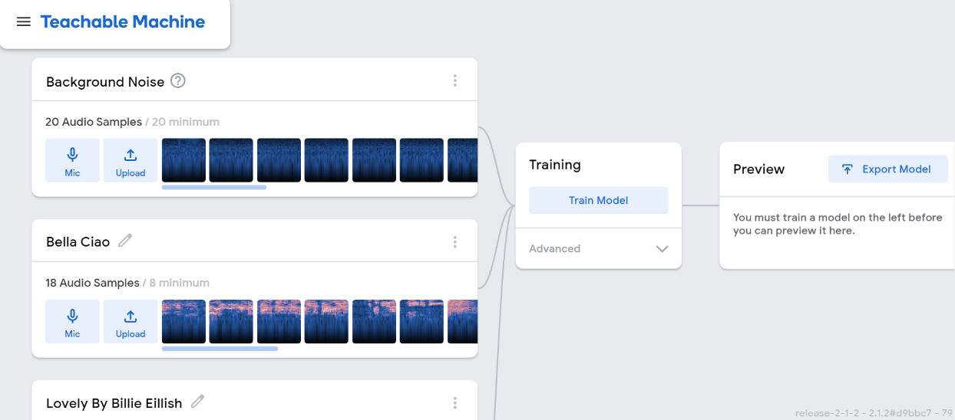

Data Modelling 1: Gathering Data Samples

ii. *Training*

This is the second step. In this step the machine is being trained with the samples provided. The machine takes some time and learns how to interact if it hears sounds and identify if the sounds are related to sound with which the machine is being taught. It becomes better and better with experience of the machine.

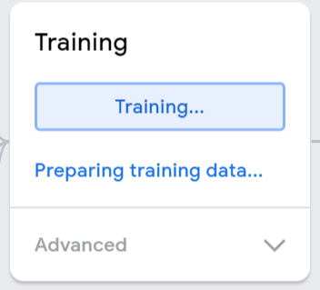

Training 1: Machine is being Trained

iii. *Debugging or Output of Machine*

The final step is finding outcome of the machine. When the machine is trained, it is ready to give output. The machine is now ready to be tested.

* 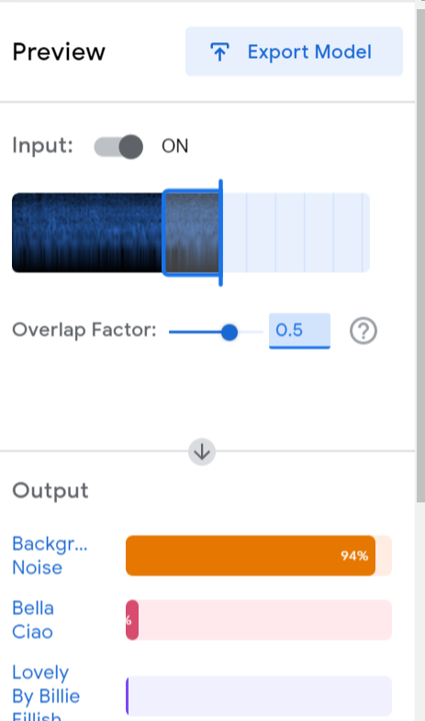**Background Noise:** First of all there was no song played and the microphone was in room and the machine was clearly showing background noise signal.

Output 1: Background Noise

* **Lovely- Billie Eilish:**  Afterwards I played Billie Eilish song named lovely and the results were:

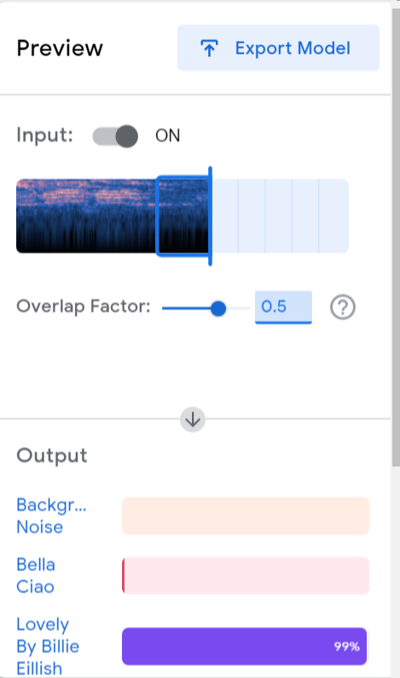

Output 2: Lovely- Billie Eilish

* **Bella- Ciao:** Then I played Bella Ciao song and the results suddenly changed to this:

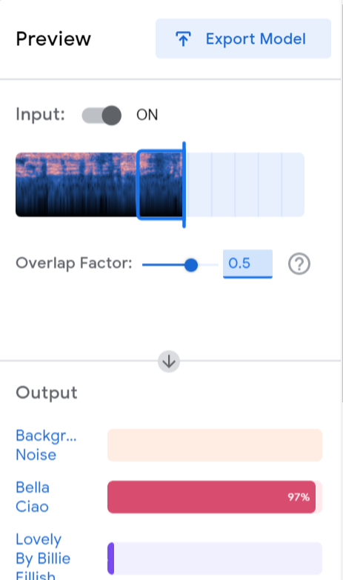

Output 3: Bella-Ciao

# 3.CONCLUSION

This report has been presented the overview of Machine Audio Detection and Identification using Machine Learning.

First, we have to provide data samples and then we have to train the machine and then the machine will give its output.

The machine was given sample of 2 different songs and background noise and the machine was trained successfully and gave the most possible outcomes.

The machine has started to learn 3 different voices and detecting and sorting these learnt voices with **Accuracy= 96.7%** which is really good at start and it will increase rapidly with experience.

# REFERENCES

1. https://www.yourdictionary.com/audio
2. https://expertsystem.com/machine-learning-definition/
3. https://towardsdatascience.com/how-to-apply-machine-learning-and-deep-learning-methods-to-audio-analysis-615e286fcbbc